

Project Report

**Online Food Ordering System**

**Project Candidates :**

**ID : 1307717 - NAME : Muhammad Faraz Kasmani**

**ID : 1309670 - NAME : Faez Sohail**

Contents

**Introduction …………………………………………………………………………….**

**Proposed Scenario …………………………………………………………………..**

**System Module …………………………………………………………………………**

**Functional Requirements …………………………………………………………**

**Online Food Ordering System**

***Introduction: –***

**Online Food Ordering System is a part of e-commerce. E-commerce or business through net means distributing, buying, selling, marketing, and servicing of products or services over electronic systems such as the Internet and other computer networks. This if we own a restaurant, we need to upload menu online to attract potential customers. The online food ordering system gives restaurants the ability to increase Sales and expand their business by giving customers the facility to order food online. With an online restaurant menu ordering system, customers can place orders online 24X7. This it is a simple, fast and convenient food ordering system giving an edge over the competition at an affordable price.**

***Proposed Solution: –***

**Internet has seen a tremendous growth in terms of coverage and awareness. So giving the business an online presence has become very crucial and important. With [Online Ordering System], we can set up we restaurant menu online and the customers can easily place order with a simple mouse click. Also with a food menu online we can easily track the orders, maintain customer&#39;s database and improve the food delivery service. We can receive order through e-mails/ fax or directly view on internet. The restaurants can even customize online restaurant menu and upload images easily. Having restaurant menu on internet, potential customers can easily access it and place order at their convenience An online food ordering system is a web-based application that stimulates the foodies (customers) to put food orders through internet by locating their favorite restaurant or nearest one. This application is based on the asp.net platform.**

***System Modules :***

***Customer :***

**1) Registration: One time Registration is required.**

**2) Login: After registration, the user can log in and access various features.**

**3) Search: In this section, users can search for dishes etc.**

**4) Filter on Food-Type should be allowed at customer level for ease of selection of**

**food items.**

**5) Online Ordering: User can select dishes and create &amp; book order**

***Admin :***

**1) Dashboard: In this section, Admin can see the overview of books available, users**

**registered, and categories.**

**2) Categories: In this section, the admin can add, and delete the categories.**

**3) Food-Type: In this section, the admin can add, or delete the food type (Veg/Non-**

**Veg etc.).**

**4) Report: In this section, Admin can generate report of various hotels and**

**customers available.**

**5) Admin can also update his profile, change the password and recover the**

**password**

**6) Admin can also check for Customer orders and Status.**

***Functional Requirements :***

**a) Easy lookup of restaurants in your area**

**b) Check Ratings and Review the restaurants**

**c) Simple, fast and convenient ordering of food**

**d) Availability of the menu online 24X7X365 – no need to recite the complete menu**

**over the phone. An online menu is ready to be viewed and printed by people.**

**e) Accurate – no more spelling out the dishes’ names.**

**f) Menu with the actual pictures of the product thereby adding to the uniqueness**

**of your online presence.**

**g) Prior knowledge of time for delivery helps prepare and provide better service.**

**h) Provides base for online promotions, electronic coupons and gift certificates**

**without needing the costly conventional media.**

**i) Receive direct customer feedback and suggestions.**

**j) Keep the customers informed.**

***ER Diagram :***

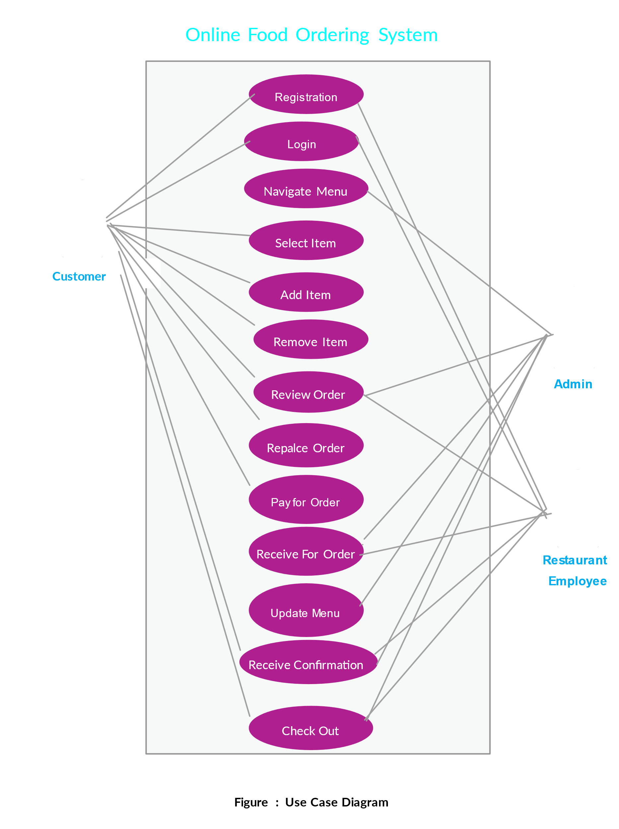

***Data Base :***

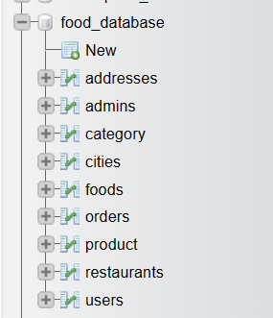

***Foods :***

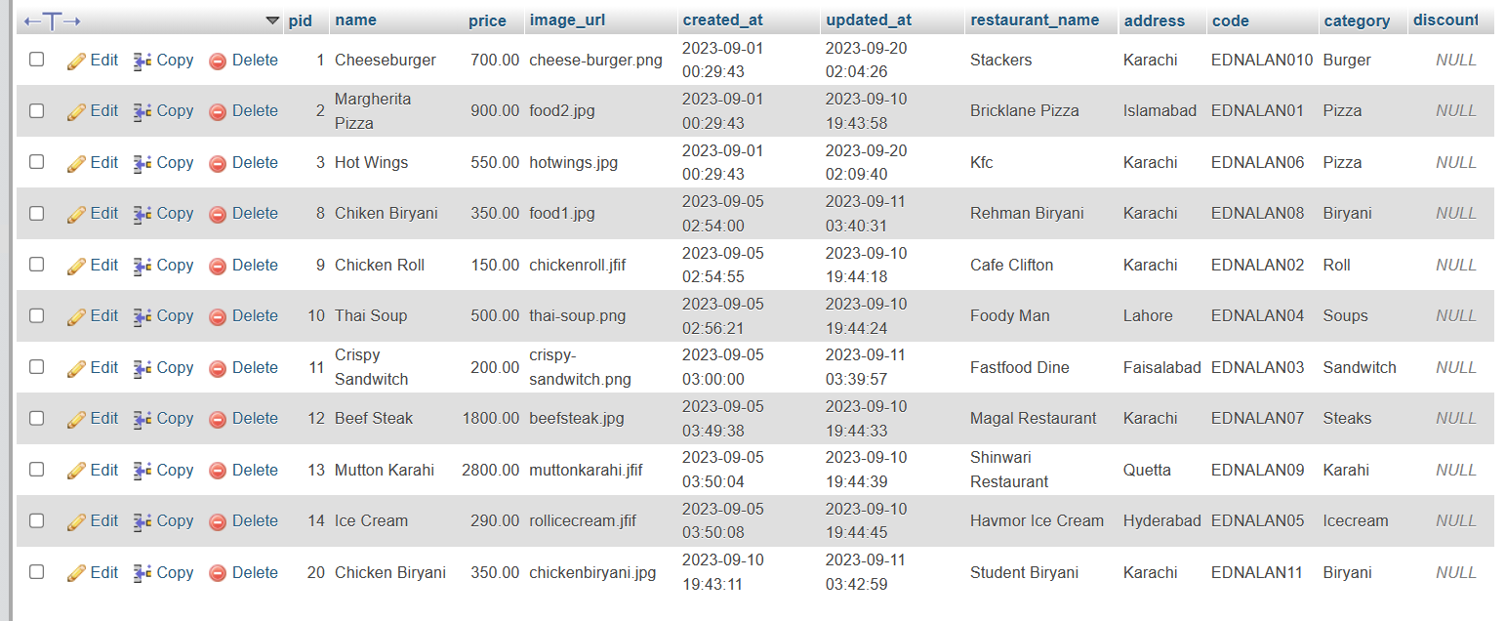

***Category :***

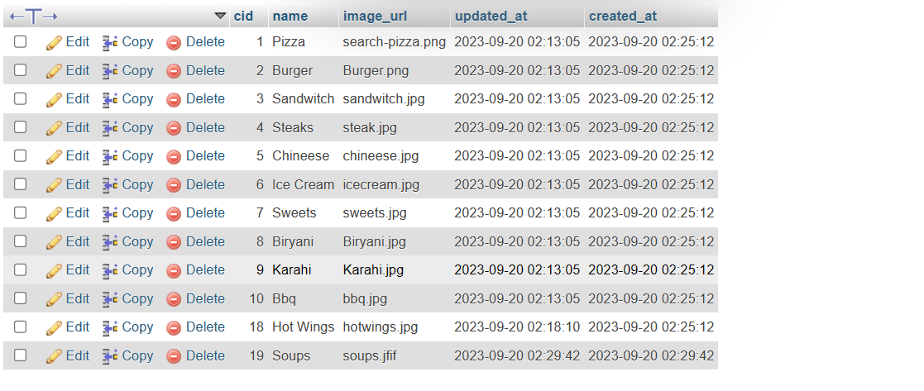

***User Panel :***

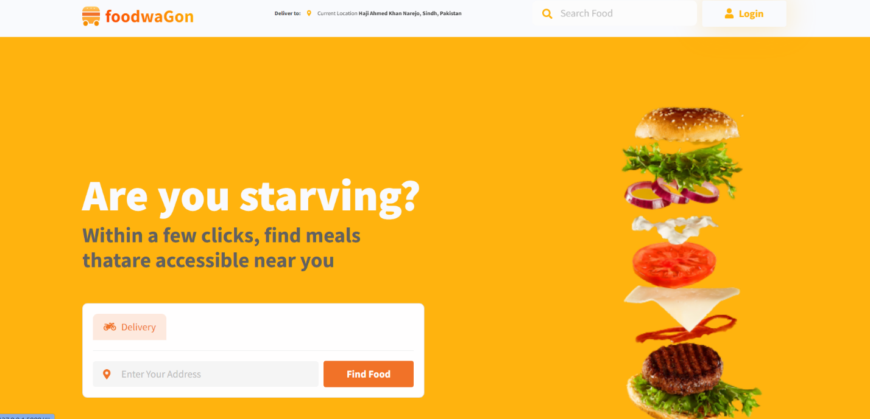

***Source Code :***

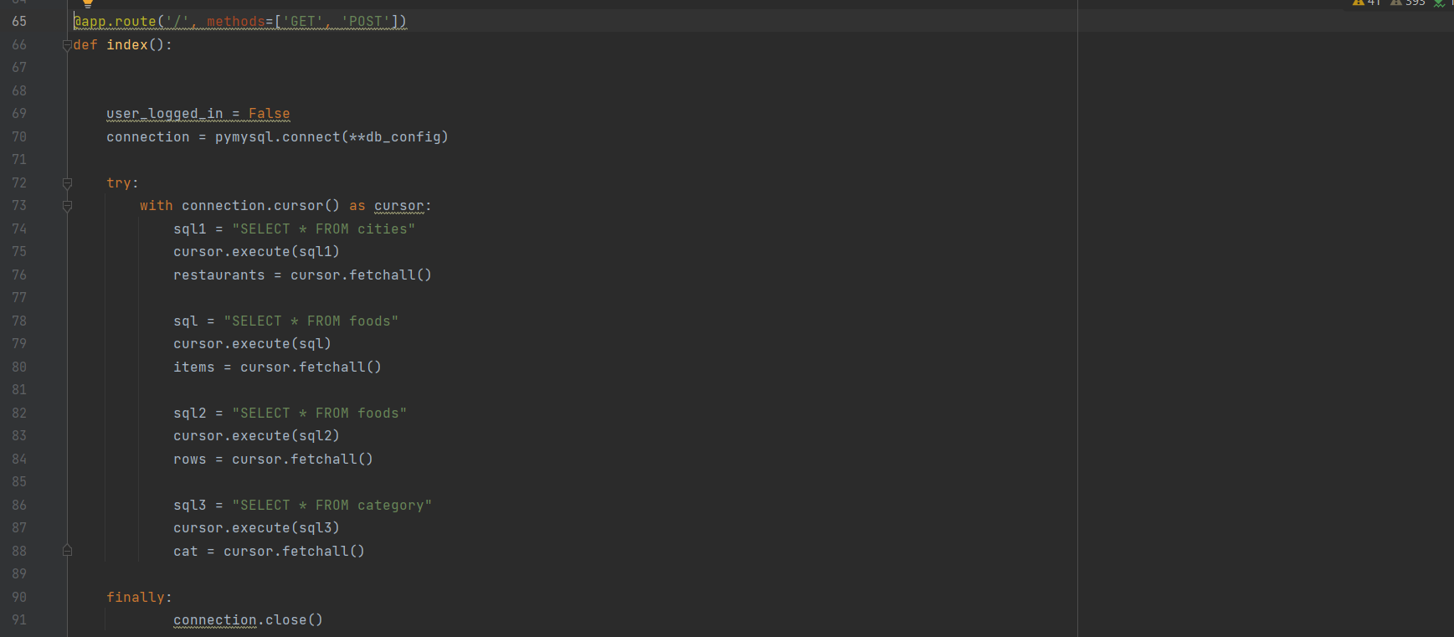

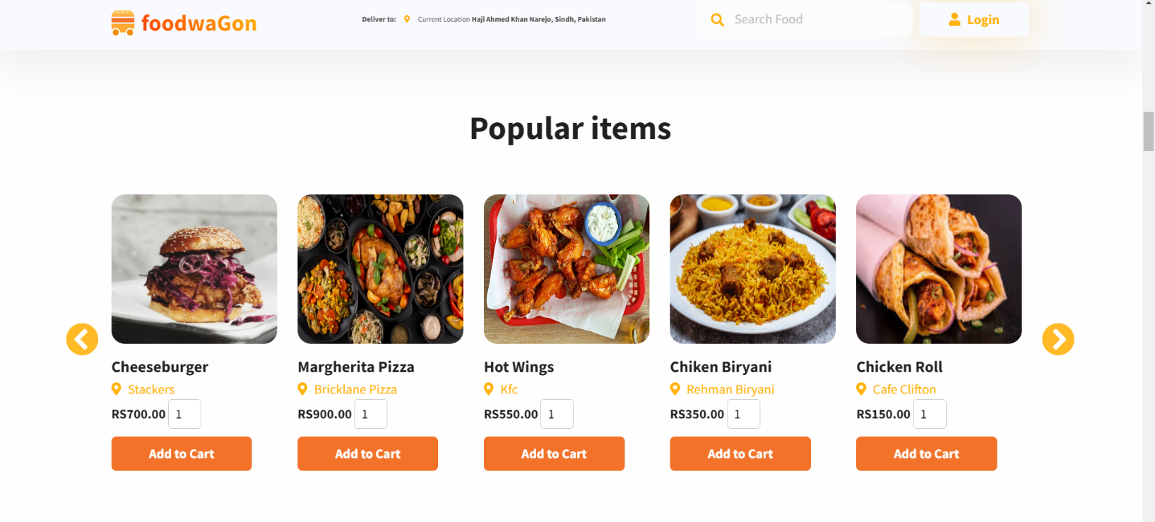

**Source Code :**

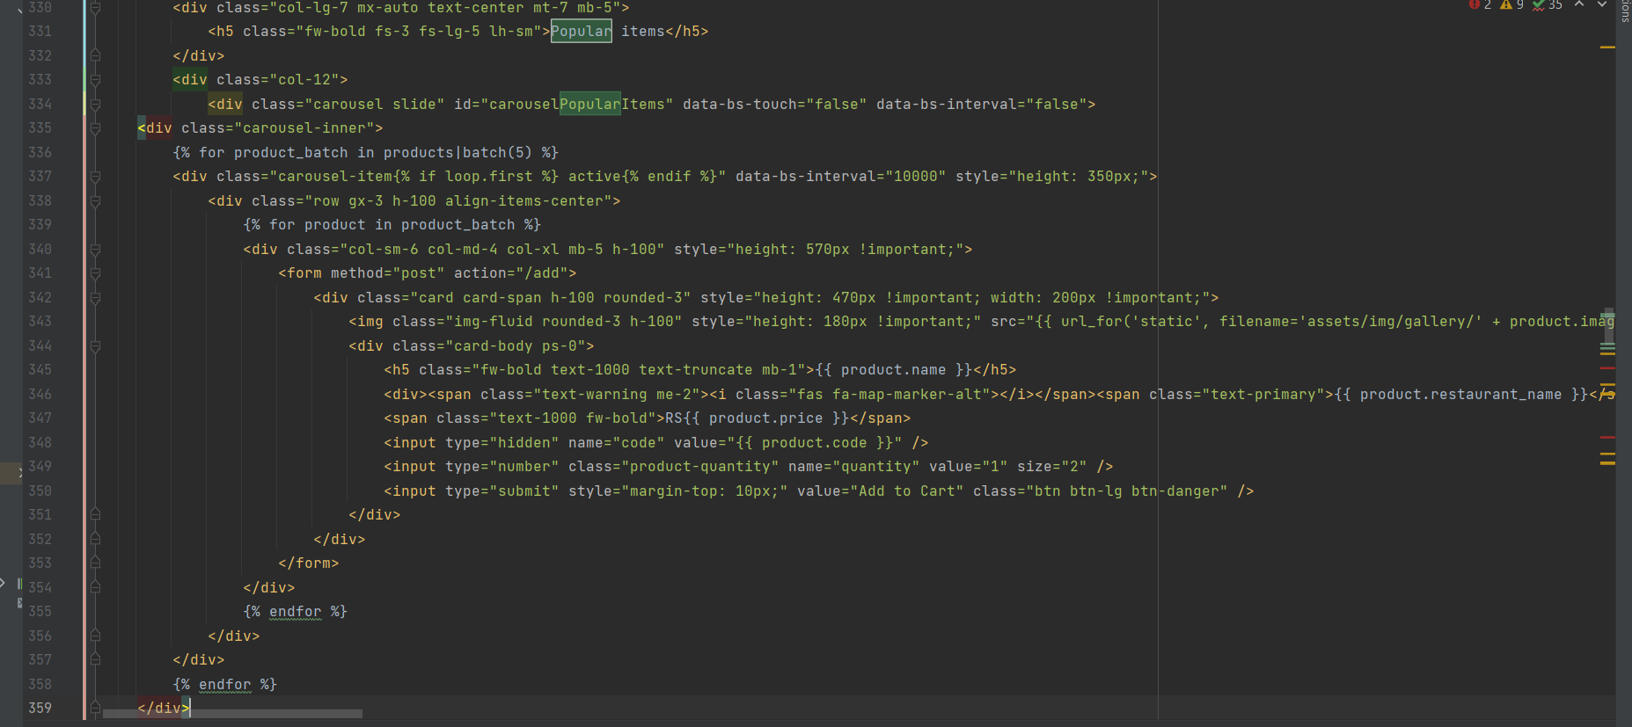

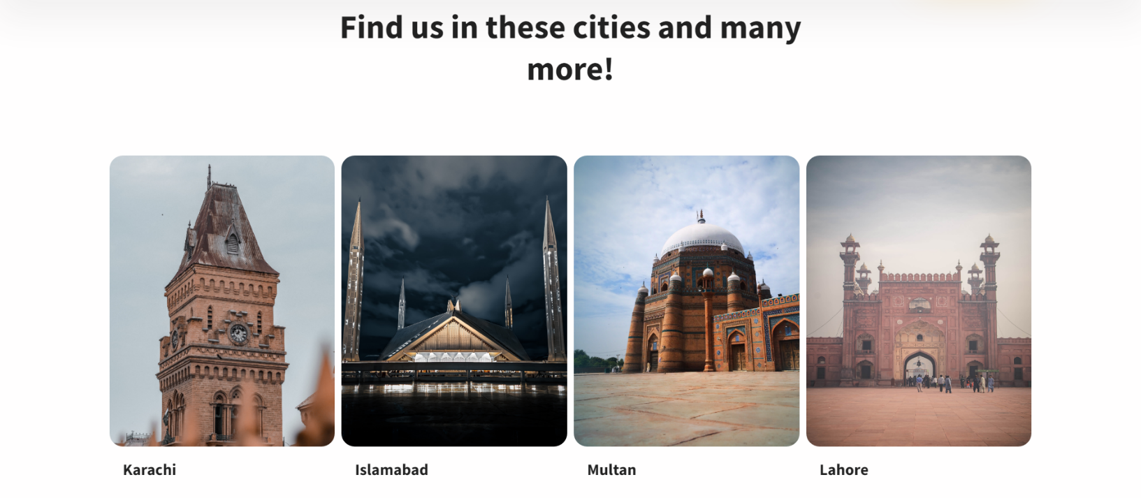

***Source Code :***

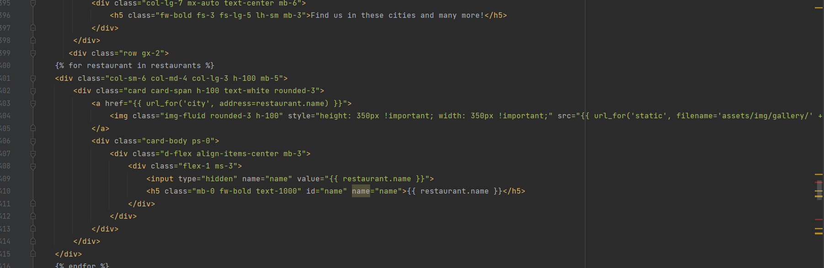

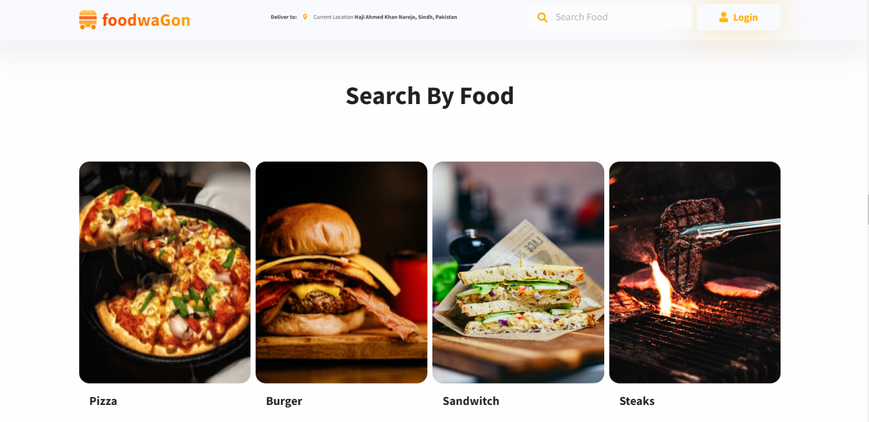

***Source Code :***

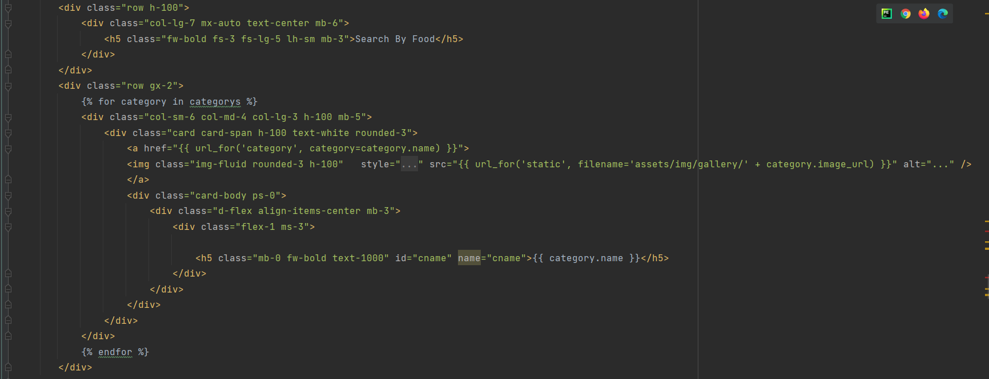

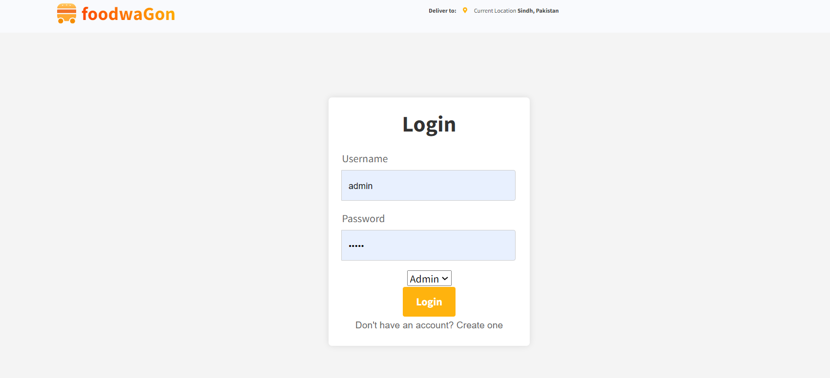

***Source Code :***

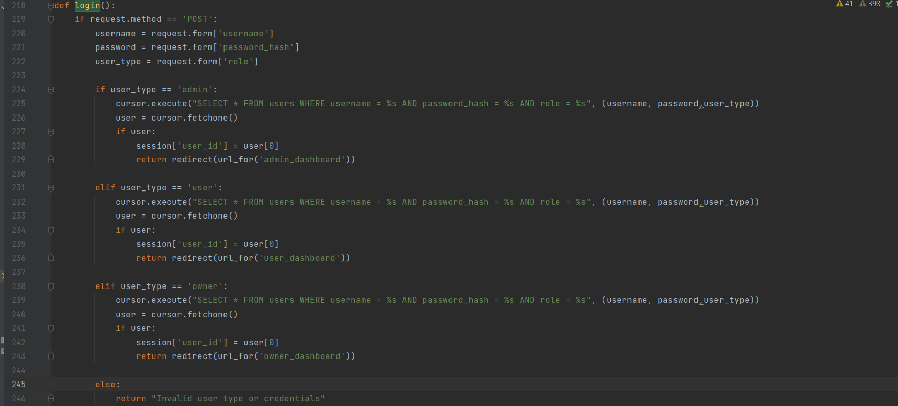

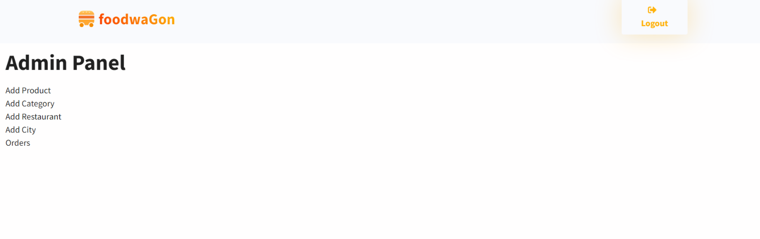

***Source Code :***

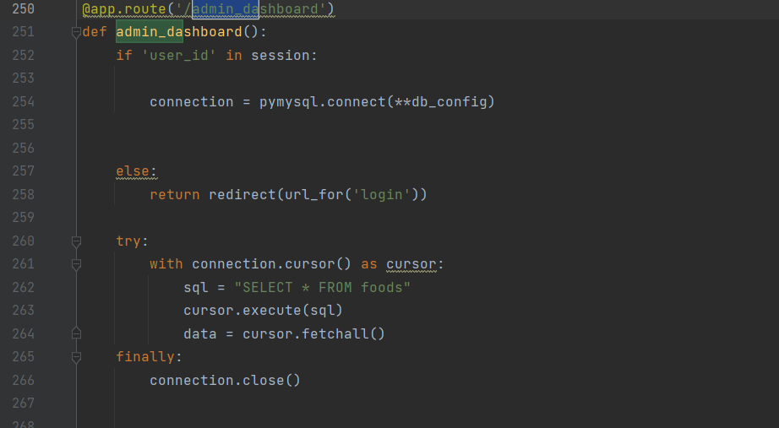

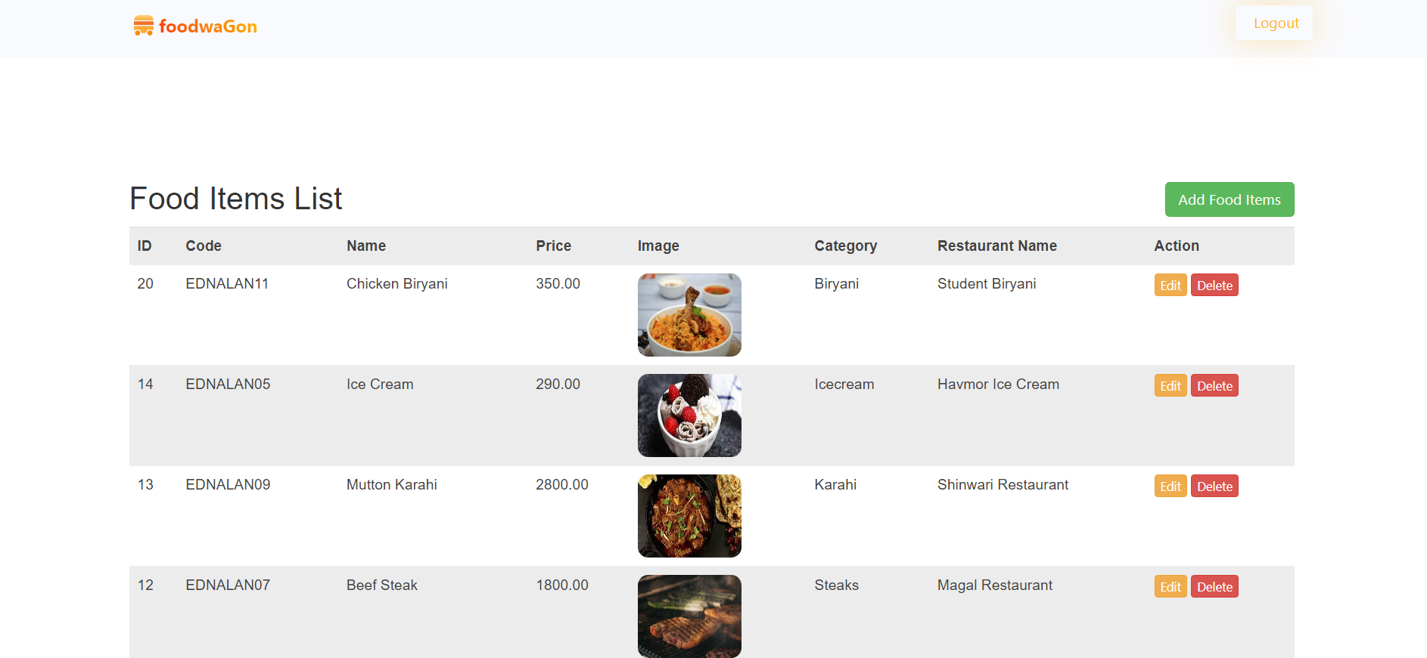

***Source Code :***

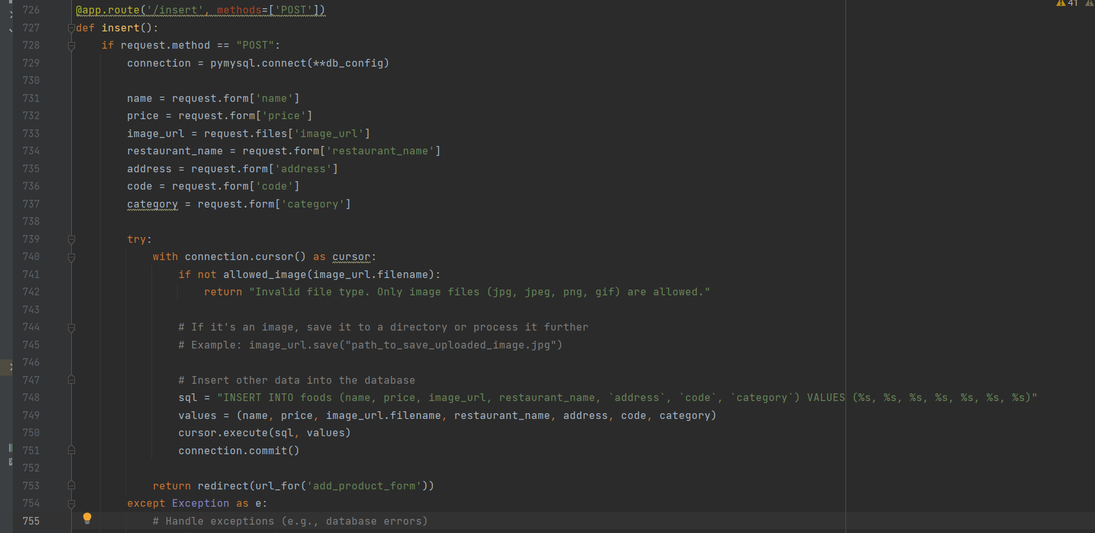

***“Thank You”***